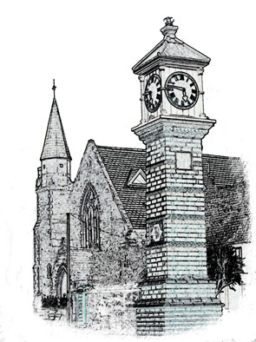

Usk Dental Practice

Date : 1 July 2020

CCTV policy

This policy describes how we comply with data protection legislation requirements in our use of CCTV.

Ownership and operation of CCTV
Miles Gladson has overall responsibility for CCTV at the practice and the images produced.

Vantage Systems is responsible for installing and maintaining the CCTV equipment. Images are stored only in the practice. Miles Gladson is ultimately responsible for the information obtained from CCTV use at the practice.

The CCTV is operational 24/7

Purpose of CCTV
We use CCTV recording to:

- Protect the practice premises and property
- Increase the safety of practice patients, staff and visitors
- Deter criminal activity and anti-social behaviour
- Assist in the apprehension, identification and prosecution of offenders
- Provide evidence to a court or tribunal
- Comply with a legal obligation.

Location of CCTV
CCTV cameras at the practice cover the following areas:
Reception

The CCTV does not have audio recording capability.

The CCTV monitors (screens) are located in Reception

Use of CCTV recordings
CCTV images and recordings are personal information and, when using or processing the information, we will respect the legal rights of the individuals shown in the recordings.

We will not share images or recordings except in the following circumstances:

- If requested by the local authority, police or courts for the investigation, prevention or prosecution of anti-social behaviour or criminal activity
- For bringing or defending a legal claim
- To comply with a police warrant or an order given by a court or tribunal.

Access to the CCTV monitors and/or recorded images, for the purposes listed above, is restricted to Miles Gladson

The CCTV equipment will be checked regularly to ensure that it is in good working order and images recorded are of a sufficient quality to be used for the purposes listed.

CCTV images and recordings will be kept for one month unless they are being used in the investigation of an incident (for example theft, damage or violence). After this time or following the conclusion of an investigation, the recordings will be destroyed and/or irretrievably deleted.

Requests for CCTV recordings
Requests by individuals for recordings of themselves are will be processed in line with the practice policy on access to information.

Requests by third parties (such as law enforcement agencies or lawyers) for practice CCTV recordings should be submitted in writing to Miles Gladson. He will then:

- Verifies the identity of the person / organisation and takes a copy of any identification documents, if required.
- Decides whether providing the CCTV recording would satisfy one or more of the purposes listed in this policy.
- Considers the rights of the individuals shown in the CCTV, and balances the protection of these rights against the reasons for the request. Some images may require editing to protect the privacy of individuals.
- If appropriate, transfers the requested CCTV recordings / images securely to the third party.
- Keeps a record of the disclosures of CCTV to the third party.

If unsure about providing the requested information to a third party, Miles Gladson should seek advice from the Information Commissioner’s Office (ICO).

Review
This policy will be reviewed at least every three years as stated in the attached checklist.

Complaints
Any concerns or complaints about this policy should be raised with Miles Gladson. If the concerns cannot be resolved, the practice may seek advice from the ICO.

Review checklist
[2020]

Action | Date checked | Checked by | Review date
Privacy impact assessment conducted | 22/5/2020 | MG | May 2023
ICO notified that CCTV recordings are made at the Practice, and next renewal date noted | 22/5/2020 | MG | May 2023
Following problems identified:  Less intrusive alternatives to CCTV surveillance considered but concluded that CCTV is best way to address these issues | 22/5/2020  none | MG | May 2023
Potential impact on individual privacy identified and considered | 22/5/2020 | MG | May 2023
The CCTV system produces clear images that can be used for the intended purpose | 22/5/2020 | MG | May 2023
CCTV cameras positioned to cover the areas to be monitored. Images of people who are not entering the practice are not captured | 22/5/2020 | MG | May 2023
Visible signs show that CCTV is in operation | 22/5/2020 | MG | May 2023
Data processing agreement in place between the practice and the CCTV system providers | 22/5/2020  n/a | MG | May 2023
A practice policy explains how individuals can obtain copies of their own images | 22/5/2020 | MG | May 2023
CCTV images are retained only for as long as is necessary and then securely deleted | 22/5/2020 | MG | May 2023

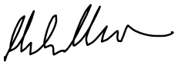

1 July 2020

Review date: 1 year.

