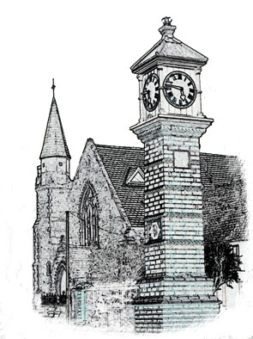

Usk Dental Practice

Date : 1 July 2020

Code of practice for handling patient complaints

We want our service to meet your expectations. If you have a concern or complaint about any aspect of our service, we want to know what mistakes we made and identify how we can improve to ensure that we meet your expectations in future. Our aim is to learn from any feedback we receive and improve the service we provide to our patients.

We will deal with complaints courteously and promptly and aim to resolve the matter as quickly as possible.

Making a complaint
If you wish to make a complaint or simply let us know how we could have done better, please contact Miles Gladson our Complaints’ Manager:

- By telephone on 01291 672395
- By email at uskdentists@outlook.com
- By letter to Usk Dental Practice, 4 Priory Street, Usk
- In person.

The Complaints’ Manager usually works at the practice Monday to Friday and will endeavour to be available during these times. You may find it more convenient to make an appointment with Complaints’ Manager to ensure he can dedicate sufficient time to meet with you.

If you contact the practice to make a complaint and the Complaints’ Manager is not available, we will arrange a convenient time for them to contact you. We will ask you for brief details of your complaint so that the Complaints’ Manager can gather any useful information before contacting you. You will be given a copy of the notes made for the Complaints’ Manager.

If the matter requires a more immediate response, we will arrange for a senior member of the dental team to deal with it.

If your complaint is about your dental treatment or the fee charged, we will usually ask the dentist concerned to contact you, unless you do not want this.

We acknowledge all complaints in writing and enclose a copy of this code of practice as soon as possible, normally within 2 working days.

Investigating a complaint
We will offer to discuss the complaint with you and will ask how you would like to be kept informed of developments – by telephone, letters or e-mail or by face-to-face meetings. We will let you know how we will deal with your complaint and the likely time that the investigation will take to complete. If you do not wish to discuss the complaint further, we will still let you know the expected timescale for completing the investigation.

We will investigate your complaint within 4 weeks and, as far as reasonably practicable, will let you know how our investigation is progressing.

When we have completed our investigation, we will provide you with a full written report, unless you have told us that you do not wish for further communication. The report will explain how we considered the complaint, the conclusions we reached for each part of your complaint, details of any remedial action we have taken and whether further action is needed.

Records
We keep proper and comprehensive records of any complaints that we receive and the action we have taken following investigation. We review these records regularly to ensure that we recognise our mistakes and take every opportunity to improve our service.

If you are not satisfied
If your complaint was about your dental treatment and you are not satisfied with the result of our investigation, you can take up the matter with a relevant external organisation.

For complaints about NHS treatment:
ENGLAND:
The Parliamentary and Health Service Ombudsman, Millbank Tower, Millbank London SW1P 4QP (0345 015 4033 or www.ombudsman.org.uk).

WALES:
ABUHB Headquarters, St Cadoc's Hospital, Lodge Road, Caerleon, Newport, NP18 3XQPublic Services Ombudsman for Wales, 1 Ffordd yr Hen Gae, Pencoed CF35 5LJ
(0300 790 0203 or www.ombudsman-wales.org.uk)

For complaints about private treatment:
Dental Complaints Service, 37 Wimpole Street, London W1G 8DQ
(020 8253 0800 or online at https://contactus.gdc-uk.org/dcs/Complaint/PrivatePatients).

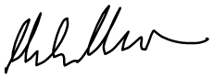

1 July 2020

Review date: 1 year.

