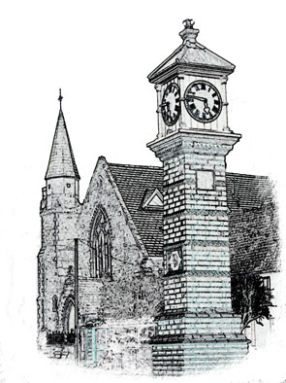

Usk Dental Practice

Date : 1 July 2020

Electronic communications – patient notice and consent

Notice to patients
Emails and text messages are now an integral part of everyday life for many people and can improve and simplify the way we communicate with our patients. However, we will only send you emails or texts if you give us your permission to do so.

Emails and text messages are not always secure so we will not include personal information about your health, unless you ask us (in writing) to do so.

We will not pass on your contact details, including your email address or telephone number, to any third party.

If you are willing for us to communicate with you by email and/or text to remind you of booked appointments, amounts due and/or information about our services, please complete this form and return it to Miles Gladson

Patient agreement
I don’t agree that Usk Dental Practice may send me reminders and information about:

booked appointments

amounts due

services provided by the practice

I understand that I can opt in to receiving these communications at any time by speaking to a receptionist or to my dentist and asking them to amend my records.

Patient name: ______________________________________________

Patient signature: ______________________________________________

Date: ______________________________________________

Signed

Date 1 July 2020

Review date: 1 year.

