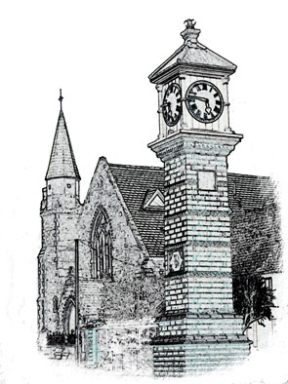

Usk Dental Practice

Date : 1 July 2020

Practice appointments policy

We endeavour to manage our appointments system to avoid delays in appointment times and minimise loss of surgery time through cancellations and failed appointments.

Practice appointment system
- We manage our appointments so that treatment appointments are booked no more than 10 weeks ahead
- We try not to keep you waiting and to see you within 30 minutes of your appointment time. Where there is a delay, we will explain the reasons.
- Where the length of your appointment is longer than 10 minutes, we will remind you of the day and time of your appointment by email
- We monitor our waiting times for (i) treatment and (ii) for booking appointments
- If we need to change or cancel an appointment, we will give you as much notice as possible, and explain the reasons
- We will let you know if there is a change in the dentist that you will see, and explain the reason for the change

Communications
- We will be courteous, friendly and professional always
- We will respond promptly to telephone calls and never ask you to ‘hold’ without first finding out why you have called
- You will receive full information about our services and our policy for collecting fees, including the methods of payment that we accept
- We will explain your treatment options and costs, answer your questions and allow you time to consider the best for you
- We will provide a treatment plan and estimate of costs for each new course of treatment and seek your full and specific consent before providing any treatment
- We will provide urgent advice and care during practice hours as soon as is practicable. Outside normal surgery hours, advice is available from 01633 744387
- We will refer you for further professional advice and treatment when appropriate
- We will respond to correspondence within five days of receipt
- We encourage you to provide feedback; we will listen to your views and learn from them
- We make it easy for you to complain or raise a concern about any aspect of the care or service that you have received. Our procedure for dealing with complaints is available at the information point

We ask that you
- Participate in your dental treatment, particularly any advice about prevention and diet that we have asked you to continue at home
- Arrive on time for your appointment
- Let us know if you are unable to keep your appointment; please give at least 24 hours’ notice. We may charge for missed appointments where we have not been notified and if you miss an appointment on more than one occasion without letting us know, we may need to review future provision of treatment for you at the practice.
- Tell us if your contact details (address, telephone numbers, email) change so that we can keep our records up to date and ensure that we are able to contact you
- Treat our staff courteously; they will do their best to help meet your needs

Signed

Date 1 July 2020

Review date: 1 year.

